1. 
2. 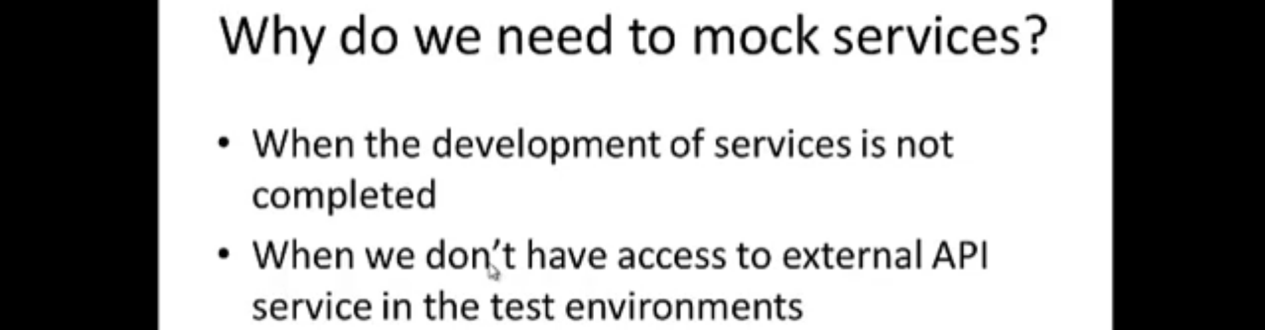
3. Let’s take an example of why we need to mock a server.
4. Suppose we have Flipkart application which we want to test.
   1. But Flipkart has downstream engagement with payment service using paypal in production but in other environments like dev, QA, staging etc, we might not have downstream engagement.
   2. Then we need a mock service that impersonates like the paypal service and it should take request and send response like a real transaction.
5. The lec was skipped from   
   <https://youtu.be/sCS_jBn5Ke4?list=PLhNpGuN8mVmF87exyR5OSoSSjNEx8-qn5&t=821>